Laptop Price Analysis using Python

NAME | SANJEEV S
COURSE | DA & DS
BATCH | AUGUST
DATE | 07 – 12 -2025

TABLE OF CONTENTS

S.NO | TITLE
1 | INTRODUCTION
2 | AIM
3 | PROBLEM STATEMENT
4 | PROJECT WORKFLOW
5 | DATA UNDERSTANDING
6 | DATA CLEANING
7 | STATISTICAL ANALYSIS
8 | EXPLORATORY DATA ANALYSIS (EDA) - UNIVARIATE ANALYSIS
9 | BIVARIATE ANALYSIS
10 | MULTIVARIATE ANALYSIS
11 | OVERALL INSIGHTS FROM ANALYSIS
12 | CONCLUSION

INTRODUCTION

Laptop sale analysis is essential for understanding market trends, customer preferences, and competitive dynamics in the fast-growing technology sector. With increasing demand for laptops in education, business, and personal use, analyzing sales data helps identify popular brands, preferred specifications, and effective price ranges. This project focuses on evaluating laptop sales data to gain actionable insights that support better business decisions, improve marketing strategies, optimize inventory management, and enhance overall sales performance.

2.AIM

The aim of this project is to analyze laptop sales data to understand market trends, customer preferences, pricing patterns, and brand performance. This study helps in identifying factors that influence laptop sales, such as specifications, price range, and demand. The analysis supports data-driven decision-making for improving marketing strategies, optimizing inventory, and increasing overall sales performance in a competitive market.

3.PROBLEM STATEMENT

The laptop market is vast and diverse, with numerous brands offering devices that vary widely in terms of specifications, features, and price. Customers face difficulty choosing the right laptop due to the overwhelming options, while manufacturers and retailers struggle to optimize pricing and features to remain competitive.
Without proper data analysis, it becomes challenging to:
Understand market trends (e.g., most common screen sizes, RAM, or storage types).

4.PROJECT OVERFLOW

- Data Understanding – Checking Data Types, proper formatting, Relevant columns for analysis.
2. Removing Columns – Remove columns that are not relevant and will not provide any insights for the project.

3.Data Imputation – Impute the missing values with popular values for a categorical variable and mean for numerical variable.

4. Outlier Removal – Use Box plots and IQR Methods to remove the Outliers

5. Handling Missing Values – Further missing values remove it or fill it with ‘Unknown’.

6. Exploratory Data Analysis – Use univariate, bivariate or multivariate analysis to compare one, two or multiple variables.

7. Insights – Summarize the aggregated metrics and data findings.

8. Recommendations – propose a solution for the problem statement.

MAJOR PARTS OF THIS PROJECT

1. Data Understanding
2. Data Cleaning
- Fixing Rows and Columns
- Check Missing Values
- Check Outliers
- Fix Outliers
3. Statistical Analysis
4. Exploratory Data Analysis (EDA)
5. Insights

DATA UNDERSTANDING

DATASET DIMENSIONS - 1303 rows × 12 columns

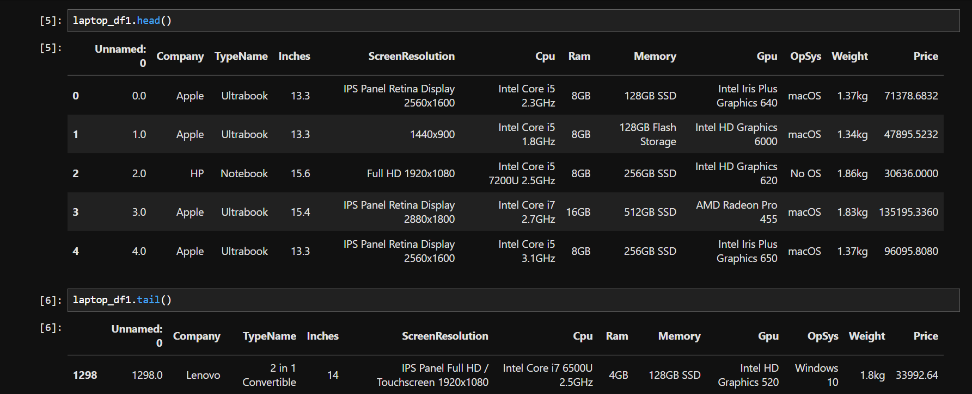

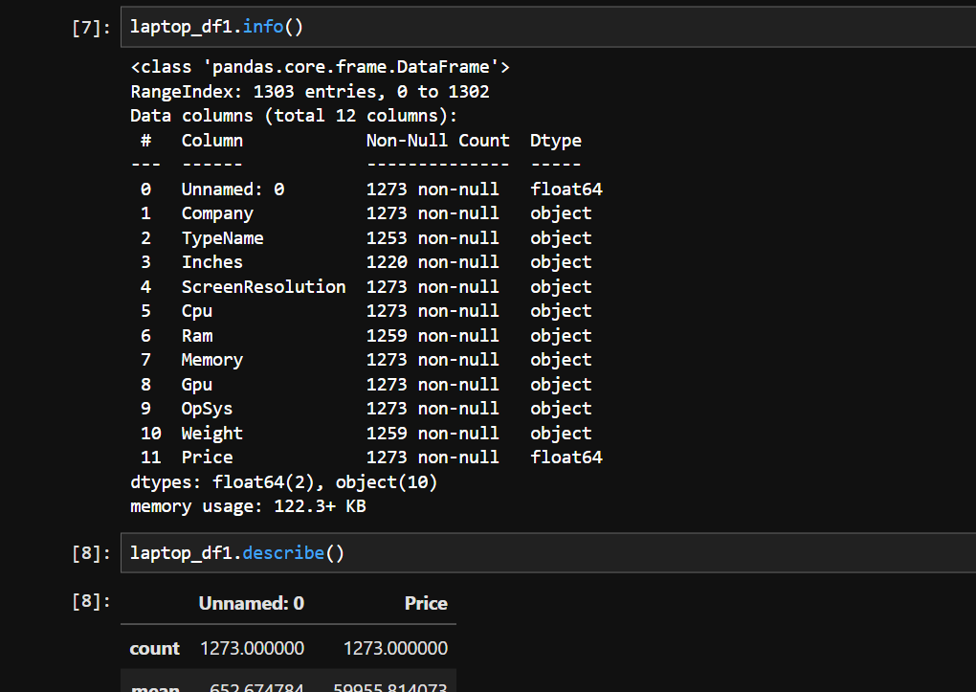

COLUMNS

  - Unnamed: 0
  - Company
  - TypeName
  - Inches
  - ScreenResolution
  - Cpu
  - Ram
  - Memory
  - Gpu
  - OpSys
  - Weight

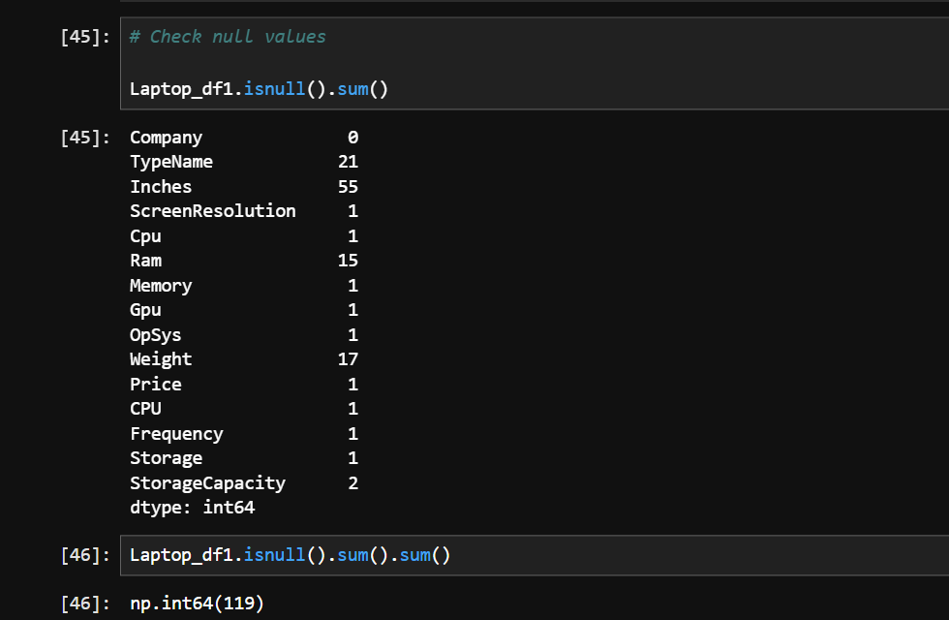

MISSING VALUES

There is no missing values in the dataset.

Except the features – ‘Price’ all other features are object.

DATA CLEANING

  - The Feature - ‘Unnamed: 0’ is just a row index.
  - So the column ‘Unnamed: 0’ is dropped.
  - Check the unique values in inches column.
  - Fix the unique values.
  - Fix the unique values for Ram column.
  - Fix the unique values for Memory column.
  - Fix the unique values for Weight column.
  - Numerical columns fill with median (Inches,Ram,Weight,price)
  - Categorical columns fill with mode.
  - Find duplicates & remove duplicates.

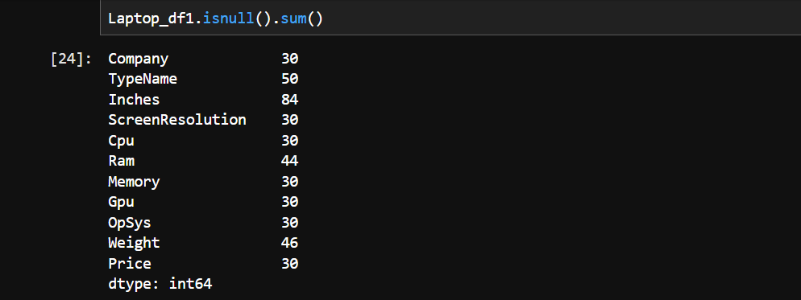

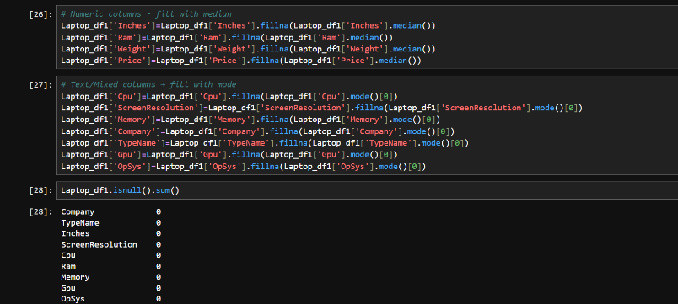

OUTLIERS

Inference: The column Inches seems to have outliers.

Because Laptops are produced in 11.6 to 8.6 inches so I removed the outliers.

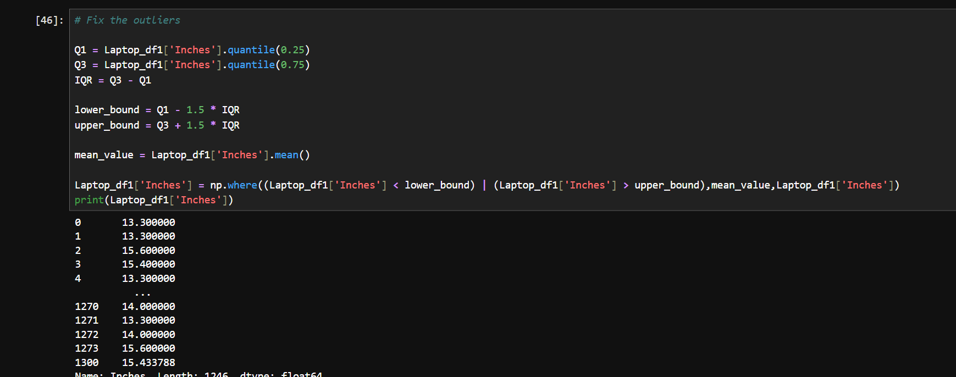

STATISTICAL ANALYSIS

DESCRIPTIVE ANALYSIS

Descriptive statistical analysis was conducted to summarize and understand the key characteristics of the laptop sales dataset. The analysis focused on important numerical variables such as price, Ram capacity, storage size, processor type, screen size, and customer ratings. Measures of central tendency, including mean, median, and mode, were used to identify the average trends in laptop pricing and specifications. The average laptop price indicates the general affordability level in the market, while the median price helps to understand the impact of high-end premium models on overall pricing.

TEST STATISTICS & HYPOTHESIS TESTING

One Sample t-test
- A one-sample t-test was conducted to determine whether the mean laptop price differs from the population mean of ₹70,000.
- So Reject the null hypothesis: The sample mean is significantly different from the population mean.

Chi Square Test
- Applied a chi-Square test of independence between laptop company and laptop TypeName.
- Null hypothesis (H0): laptop brand (company) and laptop type (TypeName) are independent of each other.
- Alternative hypothesis (H1): laptop brand (company) and laptop type (TypeName) are dependent (associated).

Two Sample Z-test
- Test if the average laptop price is different between two companies of Dell and Hp.
- HO: The mean price of Dell = mean price of HP
- H1: The mean price of Dell != mean price of HP.

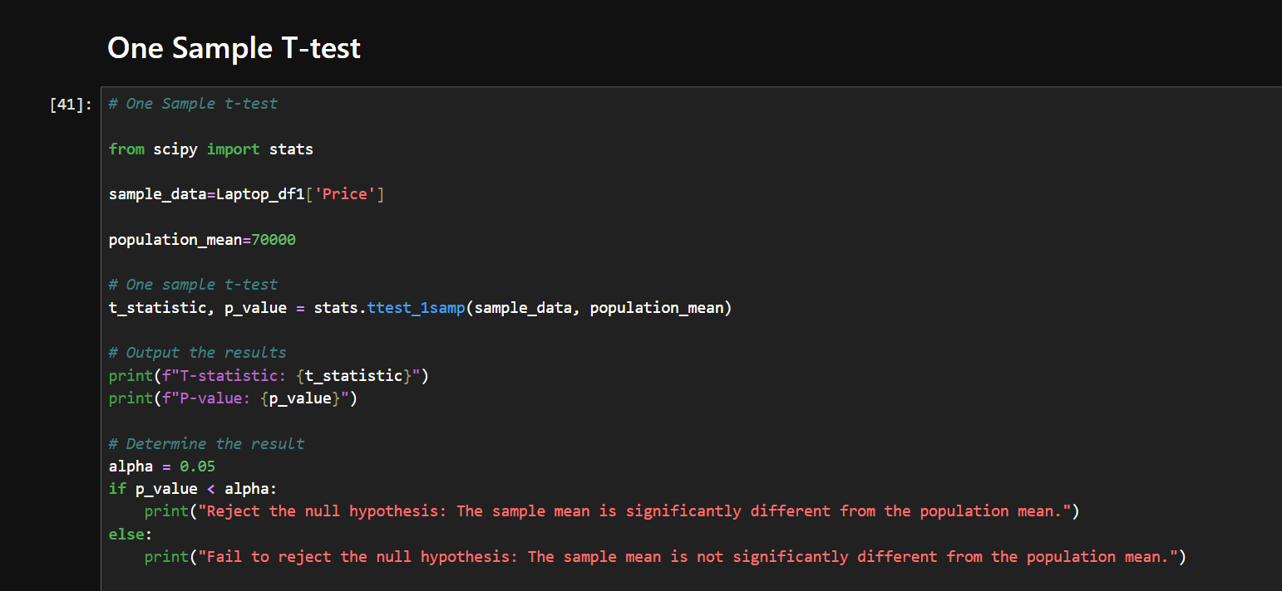

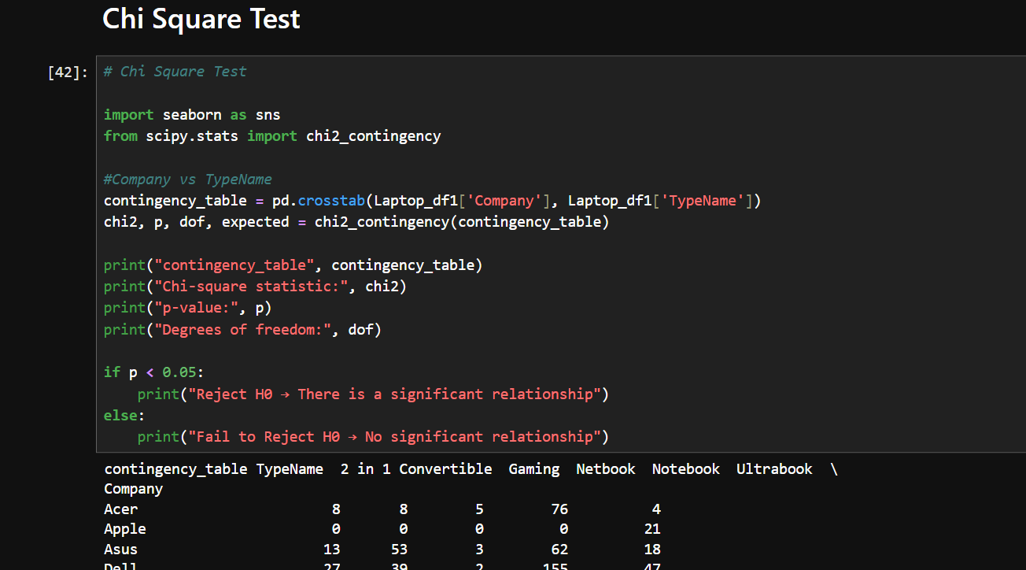

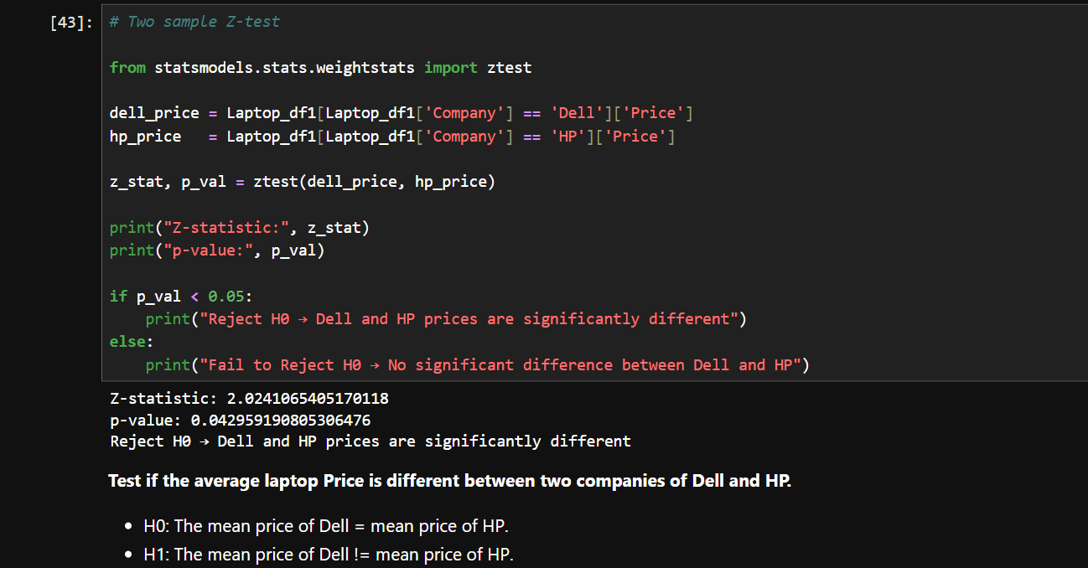

EXPLORATORY DATA ANALYSIS (EDA)

UNIVARIATE ANALYSIS

Insights:

This histogram plot shows the spread of price.

In this histogram plot laptops are highly sailed between 0 to 1 lakh.

And very low sailed laptops are between 2 lakhs to 3 lakhs.

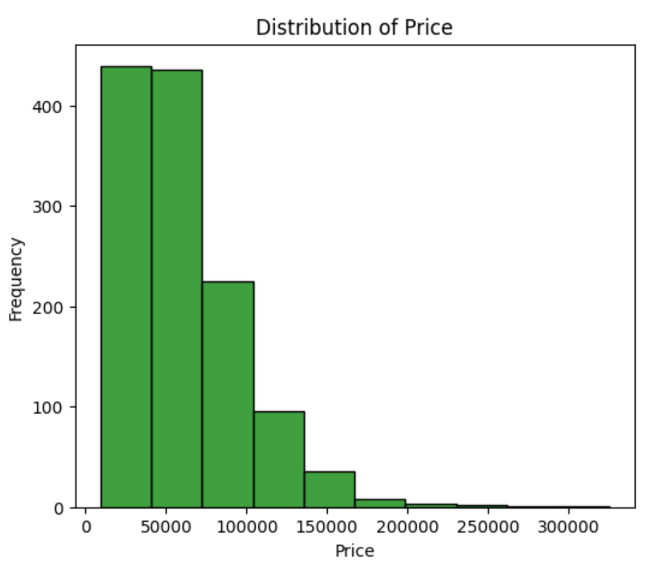

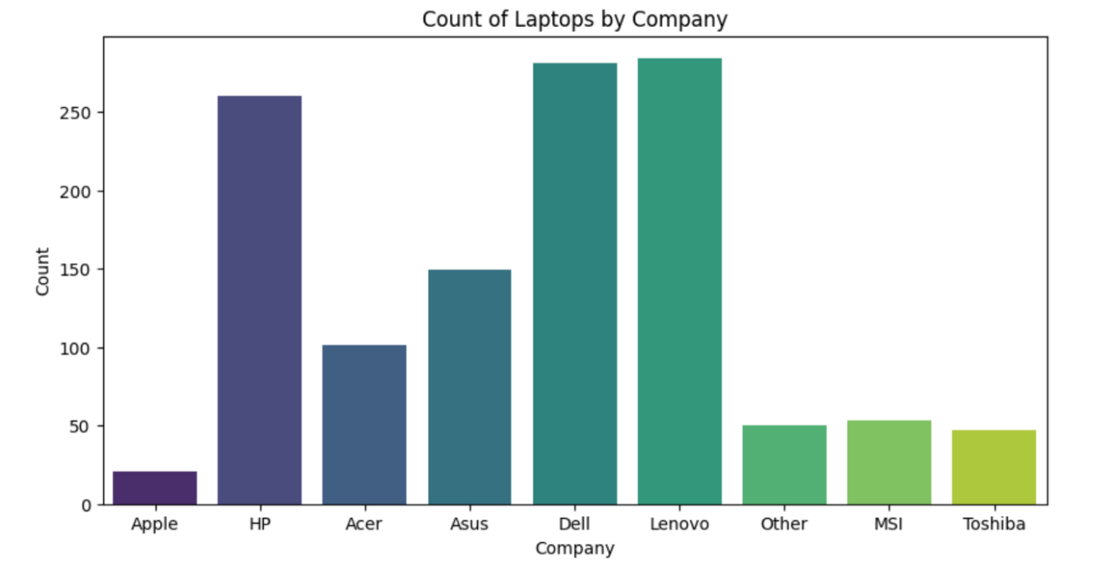

Insights:
- This count plot shows laptop counts company wise.
- In this plot Lenovo, Dell and HP is highly Sailed.
- And lowest is Apple.

BIVARIATE ANALYSIS

Insights :
- This Bar plot shows Ram wise Price
- In this plot 32GB was mostly sailed laptops.
- Mostly lowest is 2GB Ram laptops.

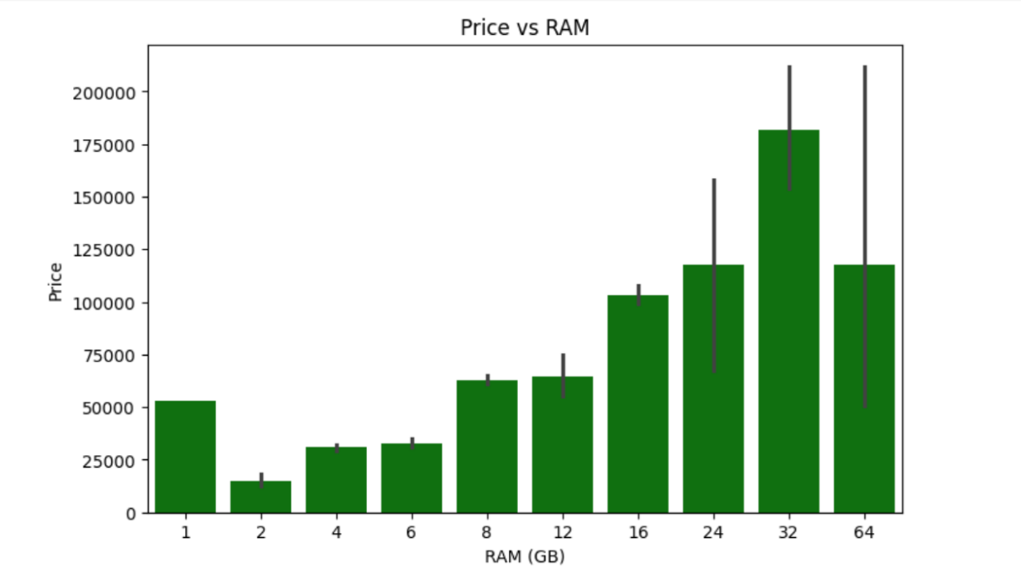

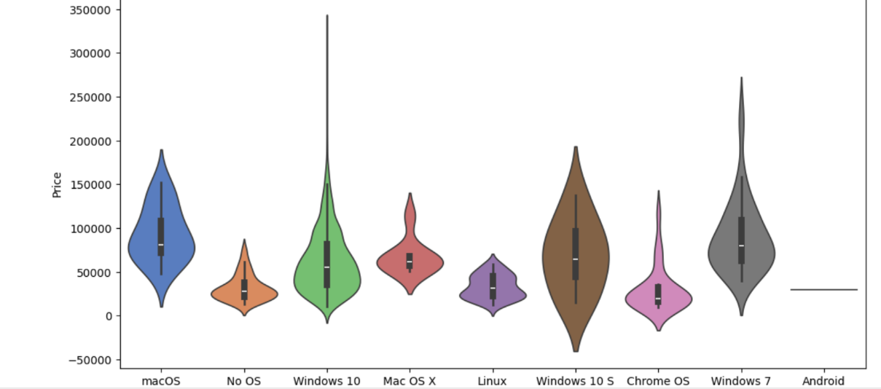

Insights:
- In this plot Windows 10 shows most high priced devices
- Lowest is Linux, chrome OS, No OS, Android.

MULTIVARIATE ANALYSIS

Insights:

This Clustered Bar Plot shows laptop price by company and type.

In this plot other company sailed the most number of gaming laptops in high price.

Notebook laptops are sailed very low to compare all companies.

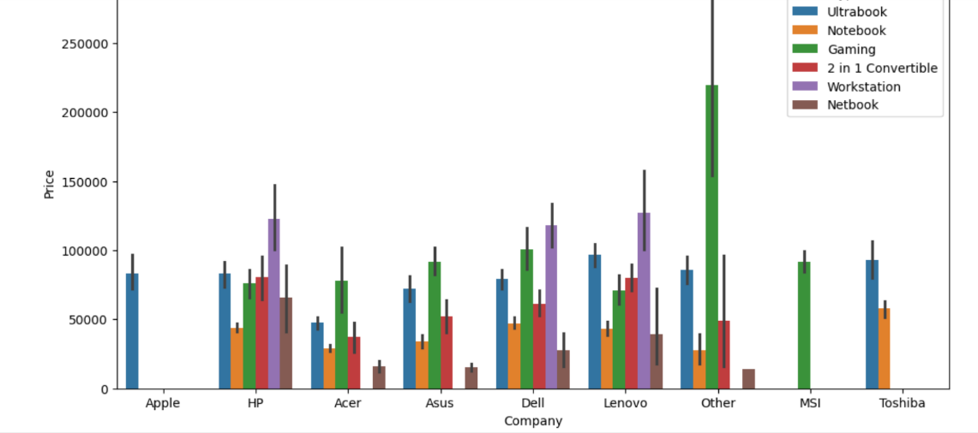

Correlation Heat

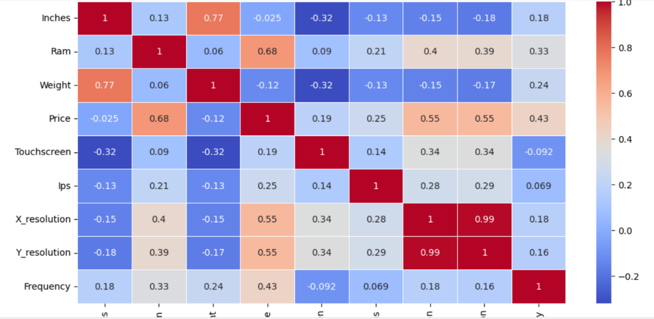

Insights:
Positive correlation
- Inches and Weight.
- Ram and price.
- Price and X_resolution , Y_resolution.
No correlation
- Price and inches
- Weight and price
Negative correlation
- Inches and Touchscreen
- Weight and Touchscreen.

Overall Insights from analysis
- Laptop prices range from Rs.9k to Rs.3.2 lakh.
- laptops are highly sailed between 0 to 1 lakh and very low sailed laptops are between 2 lakhs to 3 lakhs.
- Lenovo, Dell and HP is highly Saled and lowest is Apple.
- 32GB RAM was mostly sailed laptops and most lowest is 2GB RAM laptops.
- RAM vs Price: Strong positive correlation; higher RAM configs almost always cost more.
- Windows 10 is the most high priced devices to compare then other operating systems and lowest is Linux, Chrome OS, No OS, Android.
- Other company sailed the most number of gaming laptops high price. notebook Laptops are sailed very low to compare all companies.
- Positive correlation: Inches and Weight, Ram and price, Price and X_resolution, Y_resolution.
- No correlation: Price and Inches, Weight and Price.
- Negative correlation: Inches and Touchscreen, Weight and Touchscreen.
- Storage type price: laptops with SSD are lighter and more expensive compared to HDD models.
- GPU type: laptops with dedicated GPUs NVIDIA and AMD are more expensive, while those with integrated GPUs are cheaper.
- Operating systems: majority use Windows, followed by Mac OS (Apple). Linux/No OS laptops are cheaper.
- Brand premium: even with similar specs, Apple and MSI laptops cost more compared to Acer, Dell, or HP.

Conclusion:

The laptop sales data analysis project provided valuable insights into customer preferences, pricing trends, and sales performance across different brands and configurations. Through systematic analysis of the dataset, it was observed that factors such as price range, processor type, RAM capacity, storage, and brand reputation play a major role in influencing customer purchase decisions. The study revealed that mid-range laptops dominate the market due to their balance between performance and affordability.

